London Upgrade Defects:

Defect Number | Description | Developer who fixed it
DFCT0010570 | When upgrading to London the favorites on the menu bar is giving an error  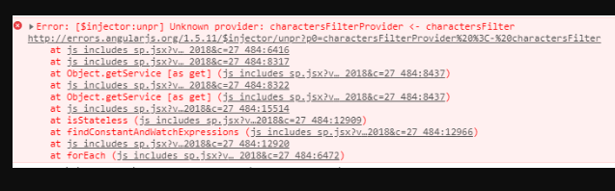 | Rob Keller
DFCT0010481 | Navigate to the portal  Navigate to the finance page  Click on contract price change  fill in the required fields  fill in effective date  See attached error (java script error)  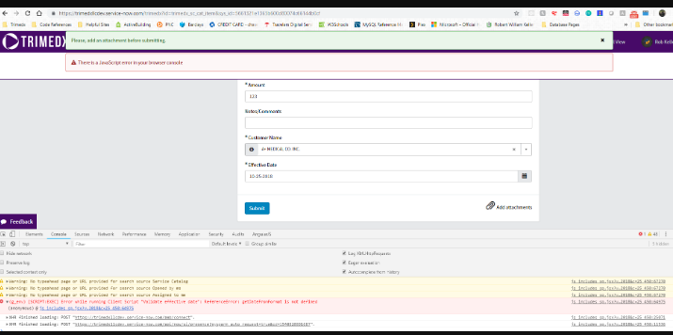 | Rob Keller
DFCT0010565 | My Approvals Tab is blank. | Rob Keller
DFCT0010622 | In Service Portal, when a user clicks into Work requested by me and they have more than a page worth of requests; they are unable to click back to page 1 if they selected page 2 at the bottom of the page.  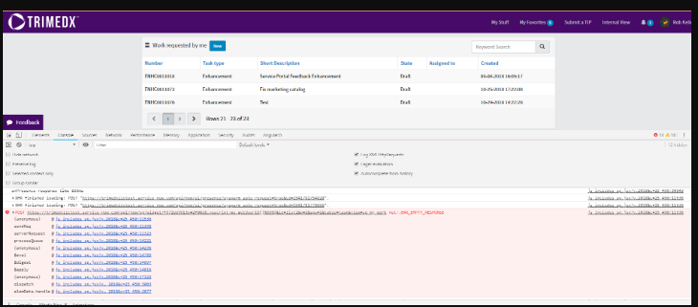 | Rob Keller
DFCT0010640 | Get Request> IT> Monitor  Select "Central Office" then move to "Ship to Another Location" then re-select "Central Office", the boxes for facility name and shipping do not disappear. In prod, switching between back to "central office", shipping fields are no longer offered. | Rob Keller
DFCT0010523 | After clicking submit on various forms you get this error There is a JavaScript error in your browser console  you can process the request thru it displays on form but quickly disappears.  All supply chain Requests. | Shiwani Upadhyay
DFCT0010535 | Navigate to adm and users  click on an existing user  change the hire date to for example todays date  click on "hamburger" and choose insert and stay  Fill in all required fields  click on order now  get error invalid text due date (see attachment) | Shiwani Upadhyay
DFCT0010580 | Java script error on the Dept updates form in Client Services This is in the Test environment  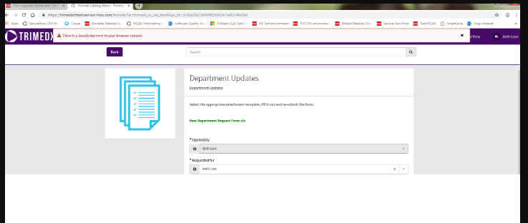 | Shiwani upadhyay
DFCT0010527 | My Entity is not listed check box is marked as required and in Test it is not.  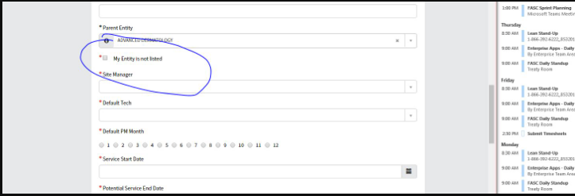 | Shiwani Upadhyay
DFCT0010597 | JavaScript Error on "New Vendor" Form  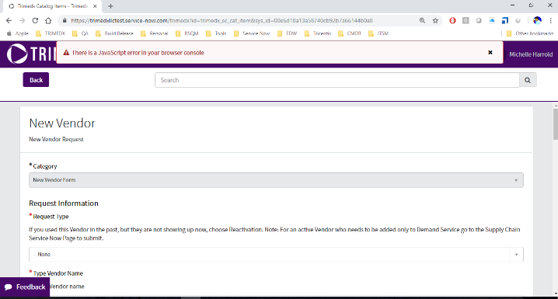 | Shiwani  Upadhyay
DFCT0010636 | Software options are not available after the new hire form is created and the manager is working the new request. | Shiwani upadhyay
DFCT0010616 | Navigate to the portal  impersonate a tech like Tim Marsh  Click on IT requests  Choose new laptop  FIll out all required fields  Submit  The approval email for (in this example) Angie Bennett is essentially blank It should have a template. See print screen and from Ryan this is the email notification script ${mail_script:IS_Template_ChangeReqApproval3}  This works this way in Dev and in test But not in PROD | Thomas Weyer
 | Regulatory Compliance v1.2.27 | Thomas Weyer
 | Tech Plus One - v1.8.0 | Rob Keller
 | Implementation v1.12.13 | Thomas Weyer

ITSM Integrations:

- Customer Information - Integration to MDM | Nightly (3:00 a.m.) | - Accounts Receivable  - Client Service Request  - Quality Incident  - Implementation Request  - AP Invoices  - Regulatory Compliance
- Vendor Information – Integration to MDM | Daily (6:00 a.m.) | - CEC\Hot Sheets  - Trimedx Service Operations (ISP Catalog)  - AP Invoice  - Model Name  - Supply Chain  - Marketing
- RSQM Work Order Information - Integration to MDM | Daily (9:30 a.m.) | CEC\Hot Sheets
- Equipment Information - Integration to EDW | Daily (8:00 a.m.) | - Training Request  - Client Services  - Quality Incident  - CE Contracts  - Legal Contract
- Supplier quality complaint - Integration to Pilgrim SmartSolve |  | https://ps1w2.rt.informaticacloud.com/active-bpel/rt/TMX-PLGM-Case-Integration  On supplier quality complaint submit
- Vendor Information – Integration from Informatica | Every 5 minutes (Informatica – deltas only) | Regulatory – Supplier Complaint

